Project Mech Style Guide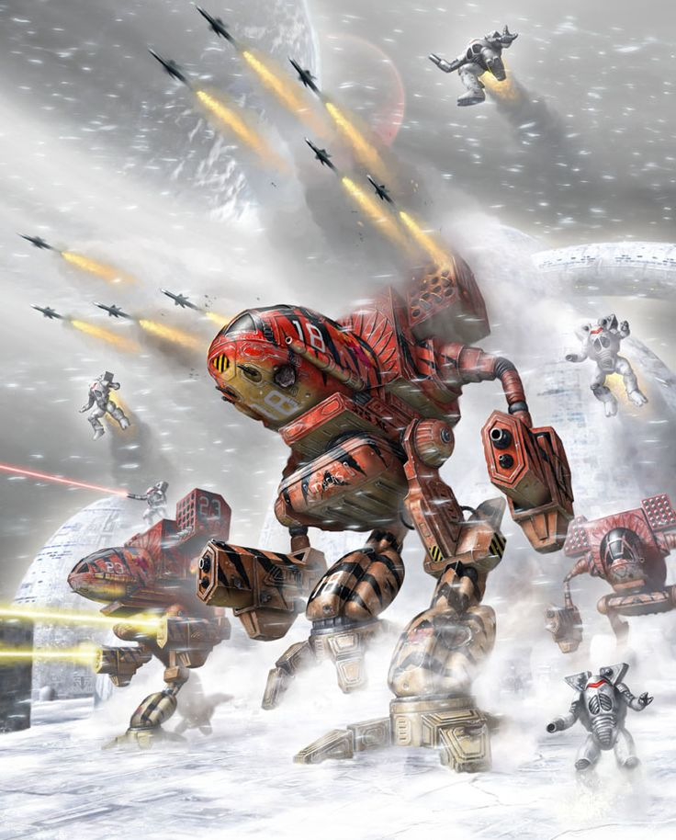

Table of Contents

1. The World
   1. The Terrain
   2. Environments
2. The Bad Guys
   1. Color Scheme
   2. Tanks
   3. Aircraft
   4. Mechs
3. The Good Guys
   1. Color Scheme
   2. Tanks(if any)
   3. Aircraft(if any)
   4. Buildings
   5. Player

The World

The game will be set on an alien world, which will allow us to have a bit more creativity with the scenery than if we just did it on Earth.

The Plan:

The environment will be dominated by soft colors, such as calm blues and brilliant purples. Green grass on most of the terrain, with several multicolored flowers that range from bright pink to royal purple (maybe even some bioluminescence going on with some of the plants). During the daytime, the sky will be a bright blue with two suns in the sky, one yellow star and a blue giant. During the night, we can have some of the plants glow as mentioned earlier. The moon will be grey with a slight blueish tint to it.

The Reason:

The cool colors are stress relieving and will make our world feel larger. They also heavily with the warm colors the bad guys will be wearing. This contrast will help make the bad guys feel more like invaders, they clash with the natural colors of this world. This will hopefully help reinforce the feeling that they are a threat that needs to be removed by the player.

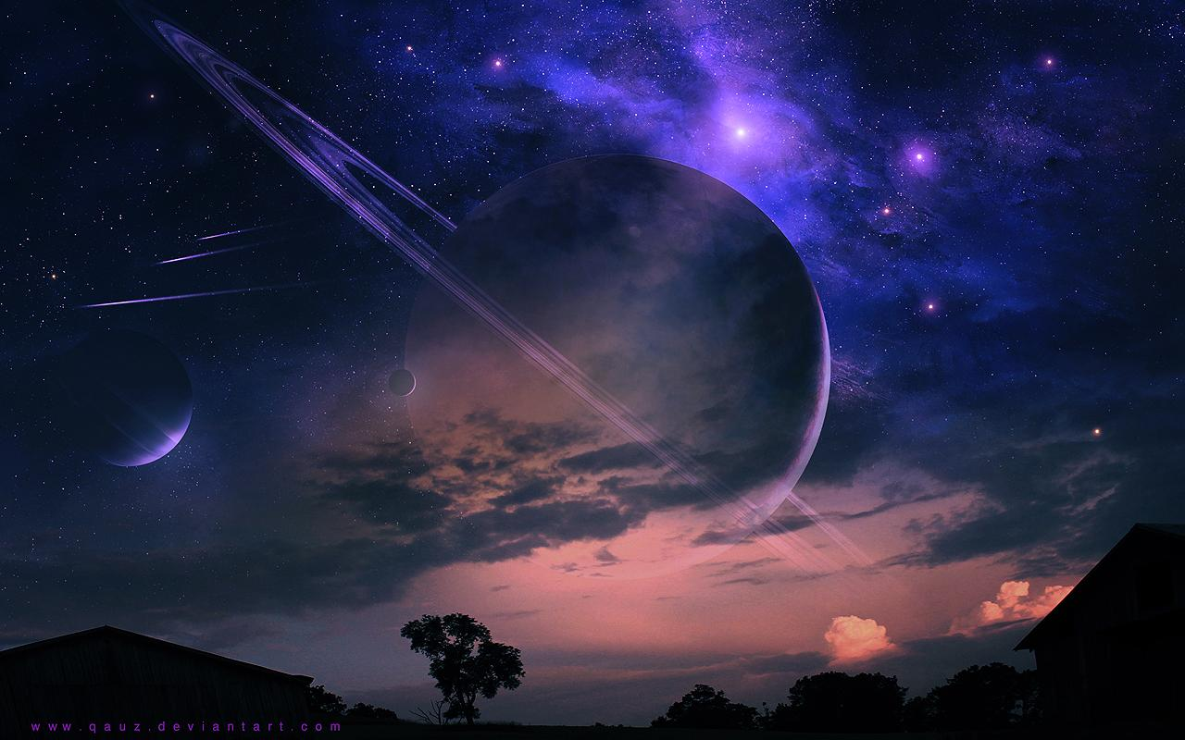

The Environments

We should have at least one daytime environment and one nighttime environment. For the sake of gameplay a cityscape environment should also be available.

The Bad Guys:

The **(insert cool sounding bad guy name here)**s should feel like out of place invaders on this world. Thus the aim is to give them a highly aggressive aesthetic to make them stand out from our hero and their friends (if they have any friends that is). The enemy force will consist of a variety of enemies including tanks, gunships, and other mechs. The possibility of enemy turrets and structures is also something to consider. The enemies will be wearing warm colors, such as bright reds and yellows, to help make them feel more aggressive. We should also avoid using the smooth function on enemy vehicles, keeping them rough and jagged-looking.

Tanks:

Tanks are a basic and common enemy in mech games. They can range anywhere from non-threatening chum used to make fights look bigger, to deadly mech destroyers that can tear apart heavy units with a hail of armor-piercing rounds.

Due to the fact that none of us either know how to/and or can’t be bothered with animating tracks, the tanks that exist in this game will be hover tanks. The tanks will ride on a cushion of air. The tanks will have armored skirts on their sides, and most will carry a war plow on the front. Light tanks can be equipped with turreted weapons, while heavier tanks will have larger guns pointing forwards. In addition to the armor worn around the air cushion, tanks will also commonly have extra armor plates that are attached to the turret and chassis.

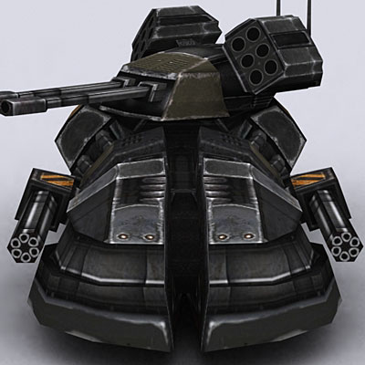

Aircraft:

Enemy aircraft are another common enemy in mech games. We will stick with VTOL style gunships. The gunships will be carried downward facing jet engines, so that we do not have to spend time animating propeller blades. Gunships will be carrying a front mounted machine gun, with another special weapon under the wings (such as missiles and rockets). Gunships need to be more sleek looking than the tanks or mechs, so no extra armor plates on them.

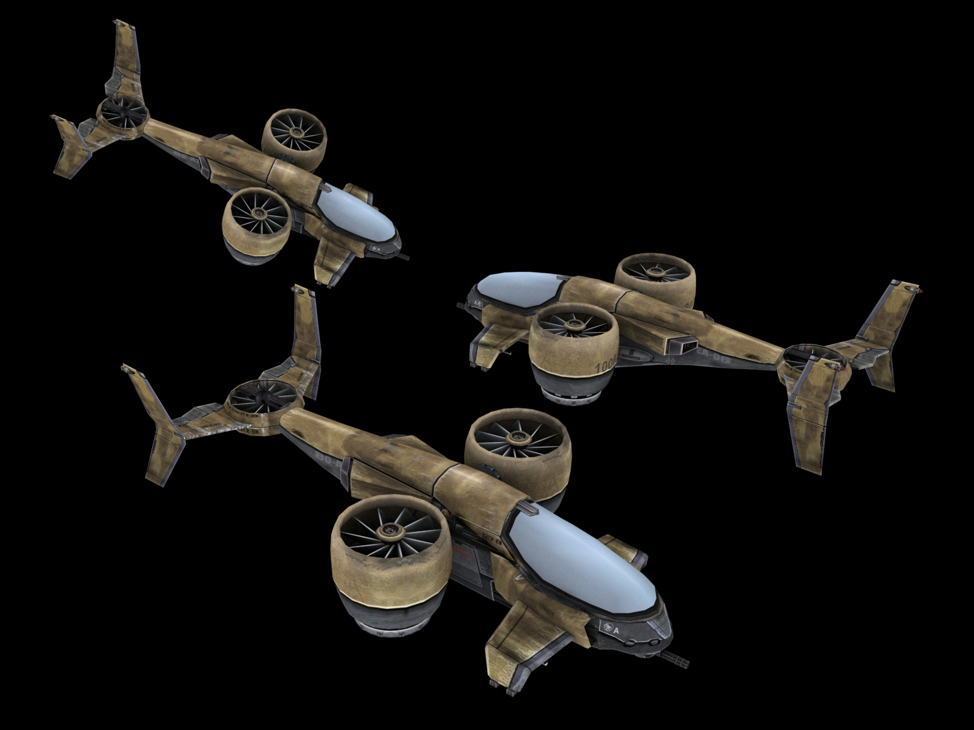

Mechs:

Enemy mechs are the biggest and toughest enemies available, the player will find even one of these to be a formidable challenge. With that in mind, enemy mechs need to be as imposing as possible. They should be large, smaller scout mechs will be marginally smaller than the player, medium mechs are a similar size to the player, and heavy and superheavy mechs are larger than the player. Enemy mechs will have extra armor bolted on, similar to tanks but in much larger quantities.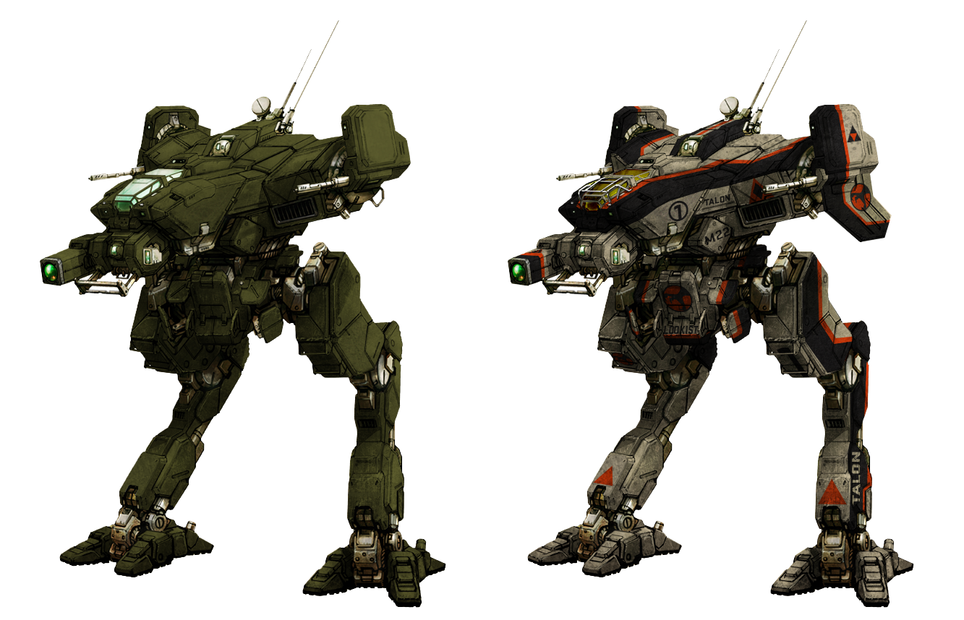

The Good Guys

Color Scheme:

For the player (and anything else that may be friendly with the player) we should use cool colors. Colors such as blue, purple, and green are calming and will make anything instantly recognizable as a friend (not lime green though, as Walt Disney has taught us, everything lime green is evil).

(going straight to player, can retroactively add the other stuff once we know if it exists)

The Player:

The player model should have a smoother look. It should be at least 1-story tall, and wear cool colors. Avoid using spikes and make it look smooth and sleek.

Buildings:

Try to keep the buildings futuristic and clean looking so that they fit in with the player more easily.